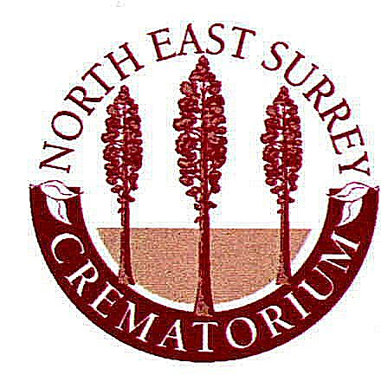North East Surrey Crematorium Board

Lower Morden Lane, Morden, Surrey, SM4 4NU
Tel: 020 8337 4835 Fax: 020 8337 8745

Date………………Interment No……………

Cremation No…………….GRANT No………………

Cremated Remains Plot
Interment Notice

- Mr Mrs Ms Miss Forenames………………………Surname……………………..

Address……………………………………………………………………………………………………………………………………………………………………………………………………………………………………………………………………………………………………………………………………………………
Post code………… Occupation………………………….Age…………………

- Date of Interment………………………………………..Year……………………………Time…………………….

- Container Casket-Urn-Box Plot Number……………………………..

- Name & Address of registered owner for 40 years right of burial

Mr Mrs Ms Miss Forenames…………………………….Surname……………….
Address………………………………………………………………………………………………………………………………………………………………………………………………………………………………………Postcode…………..Date……………Signature………………………………..Tel No ………………

Mr Mrs Ms Miss Forenames…………………………….Surname……………….
Address……………………………………………………………………………………………………………………………………………………………………………………………………………………………………………………………
Postcode…………..Date………..Signature………………..Tel No ………………

Authority of the registered owner(s), to reopen exiting plot.

Name………………………………………Signature…………….Date…………

Name………………………………………Signature…………….Date………

Funeral Director…………………………………………………………………………….…………………………………………………………………………………………………………………………………………………Tel No……………………
P.T.O

NORTH EAST SURREY CREMATORIUM BOARD

Cremated Remains Grave

Regulations

Interments & Memorials

- The Individual grave will measure 0.9m x 0.6m (3’x2’) and will accommodate up to four individual interments of ashes.
- Memorials shall not exceed 0.6m (2’) in height and width and 0.3m (1’) from front to back.
- The memorial shall be securely and properly anchored to a concrete base in accordance with the NAMM code of practice or other similar means approved by the Council. The base will measure no more than 0.6m x 0.3m x 7.6cm thickness (2’x1’x3”).
- The owner shall be entirely responsible for the safe condition and proper upkeep of the grave and any memorial placed on the grave.
- The owner is permitted to plant nothing other than annual bedding plants around the perimeter of the memorial within the grave plot. The owner shall ensure that all such plants are removed from the plot at the end of the flowering season. The planting of trees and shrubs and the placement of fencing is STRICTLY PROHIBITED. Any such items will be removed without notice.
- The placement of other items including glass vases, ceramic figures, lanterns and other personal items is at the discretion of the Board and any unsuitable items will be removed without notice.
- Ashes containers must be bio-degradable and approved by the Board.
- The graves will be allocated in numerical order by the Board.
- The scattering of ashes shall not be permitted either on any individual grave space or within the cremated remains grave area.
- In addition to the afore mentioned regulations the owner is subject to North East Surrey Crematorium Board regulations.

I the undersigned have read and fully understand the above regulations agreeing to the purchase and use of a cremated remains grave in the North East Surrey Board
Crematorium.

Signed _______________________________________ Dated ___________

Signed _______________________________________ Dated ___________

